# Comprehensive Guide: When to Use Em vs. Rem

[**Kezz Bracey**](https://tutsplus.com/authors/kezz-bracey) Jul 21, 2015

You may have come to terms with using flexible units of measurement, but you still might not fully understand when to use rem and when to use em. This tutorial will help you figure it out!

Both em and rem are flexible, scalable units which are translated by the browser into pixel values, depending on the font size settings in your design. If you use a value of 1em or 1rem, it could translate in the browser as anything from 16px to 160px or any other value.

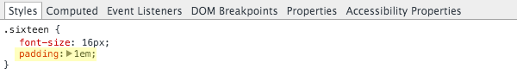CSS padding set to 1em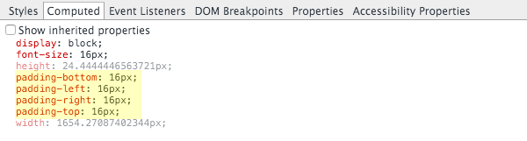Computes to 16px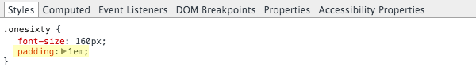

CSS padding set to 1em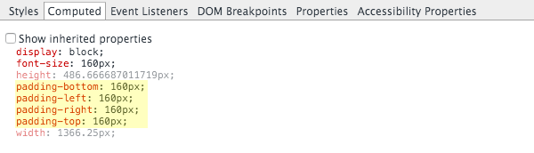Computes to 160px

On the other hand px values are used by the browser as is, so 1px will always display as exactly 1px.

Try the slider out on this CodePen example to see how the value of rem and em units can translate into different pixel values, while explicitly set px units stay fixed in size:

### The Big Question

Using em and rem units gives us flexibility in our designs, and the ability to scale elements up and down, instead of being stuck with fixed sizes. We can use this flexibility to make our designs easier to adjust during development, more responsive, and to allow browser users to control the overall scale of sites for maximum readability.

Both em and rem units provide this flexibility and work in similar ways, so the big question is, when should we use em values and when should we use rem values?

### Crucial Difference

The difference between em and rem units is how the browser determines the px value they translate into. Understanding this difference is the key to determining when to use each unit.

We’re going to begin by going over how rem and em units work from the ground up to make sure you know every detail. Then we’ll move on to why you should use em or rem units.

Finally we’ll look at the practical application of exactly which elements of a typical design you should use each type of unit on.

## How rem Units Translate to Pixel Values

When using rem units, the pixel size they translate to depends on the font size of the root element of the page, i.e. the html element. That root font size is multiplied by whatever number you’re using with your rem unit.

For example, with a root element font size of 16px, 10rem would equate to 160px, i.e. 10 x 16 = 160.

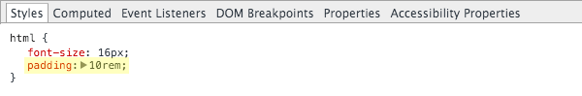CSS padding set to 10rem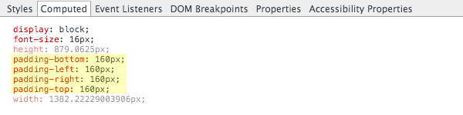Computes to 160px

## How em Units Translate to Pixel Values

When using em units, the pixel value you end up with is a multiplication of the font size on the element being styled.

For example, if a div has a font size of 18px, 10em would equate to 180px, i.e. 10 x 18 = 180.

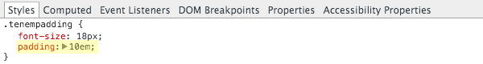CSS padding set to 10em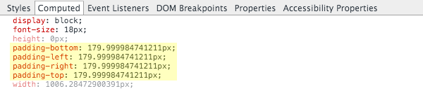Computes to 180px (or close enough to it)

#### Important to Know:

It’s a somewhat widespread misconception that em units are relative to the font size of the parent element. In fact, as per the W3 spec, they are relative to the font size [“of the element on which they are used”](https://www.w3.org/TR/css3-values/#font-relative-lengths).

Parent element font sizes can effect em values, but when that happens it’s solely because of inheritance. Let’s take a look at why, and see how this works in action.

## The Effect of Inheritance on em Units

Working with em units can start to get tricky when it comes to inheritance, because every element automatically inherits the font size of its parent. The effect of inheritance can only be overridden by explicitly setting a font size with a unit not subject to inheritance, such as px or vw.

The font size of the element on which em units are used determines their size. But that element may have inherited a font size from its parent, which inherited a font size from its parent, and so on. As such it’s possible for any em value to be effected by the font size of any of its parents.

Let’s look at an example. Feel free to try this out in [CodePen](https://codepen.io/) for yourself as we step through it. As you go along, use Chrome Developer Tools or Firebug for Firefox to inspect the pixel values our em units are computed into.

### Example of em Inheritance

If we have a page with a root font size of 16px (usually the default) and a child div inside it with padding of 1.5em, that div will inherit the font size of 16px from the root element. Hence its padding will translate to 24px, i.e. 1.5 x 16 = 24.

Then what if we wrap another div around the first and set its font-size to 1.25em?

Our wrapper div inherits the root font size of 16px and multiplies that by its own font-size setting of 1.25em. This sets the div to have a font size of 20px, i.e. 1.25 x 16 = 20.

Now our original div is no longer inheriting directly from the root element, instead it’s inheriting a font size of 20px from its new parent div. Its padding value of 1.5em now equates to 30px, i.e. 1.5 x 20 = 30.

This scaling effect can be compounded even further if we add an em based font size to our original div, let’s say 1.2em.

The div inherits the 20px font size from its parent, then multiplies that by its own 1.2em setting, giving it a new font size of 24px, i.e. 1.2 x 20 = 24.

The 1.5em padding on our div will now change in size again with the new font size, this time to 36px, i.e. 1.5 x 24 = 36.

Finally, to further illustrate that em units are relative to the font size of the element they’re used on, (not the parent element), let’s see what happens to our padding of 1.5em if we explicitly set the div to use a font size of 14px, a value not subject to inheritance.

Now, our padding has dropped down to 21px, i.e. 1.5 x 14 = 21. It is unaffected by the font size of the parent element.

With all this potential for complication, you can see why its important to know how to use em units in a manageable way.

## The Effect of Browser Settings on the HTML Element Font Size

By default browsers usually have a font size of 16px, but this can be changed to anywhere from 9px to 72px by the user.

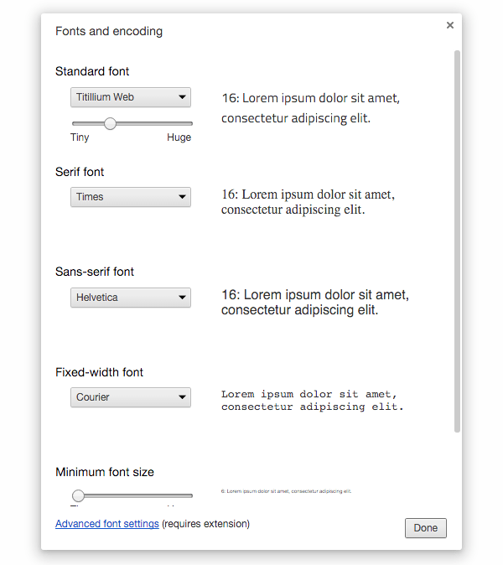

#### Important to Know:

The root html element inherits its font size from the settings in the browser, unless overridden with an explicitly set fixed value.

So while the font size on the html element is what directly determines rem values, that font size may have first come from browser settings.

Thus browser font size settings can effect the value of every rem unit used in a design, as well as every em unit via inheritance.

### Browser Setting Effect When No HTML Font Size is Set

Unless overridden, the html element it will inherit whatever the default font size setting in the browser is. For example, let’s take a site where no font-size property is set on the html element.

If a user has their browser at the default font size of 16px, the root font size will be 16px. In Chrome Developer Tools you can see what an element has inherited by checking **Show inherited properties** under the **Computed** tab.

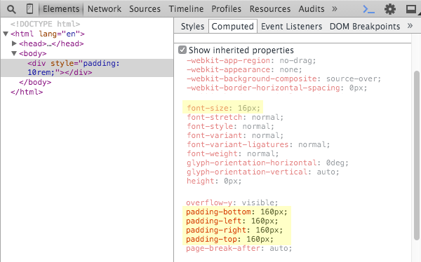

In this case 10rem equates to 160px, i.e. 10 x 16 = 160.

If the user bumps their browser font size up to 18px, the root font size becomes 18px. Now 10rem translates to 180px, i.e. 10 x 18 = 180.

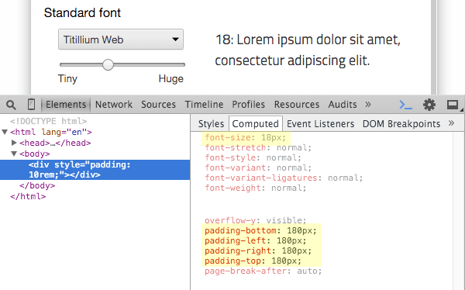

### Browser Setting Effect with em Unit HTML Font Size

When an em based font size is set on the html element, the pixel value it translates to will be a multiple of the browser font size setting.

For example, if the site’s html element had a font-size property set to 1.25em, the root font size would be 1.25 times the browser font size setting.

If the browser font size was set to 16px, the root font size would come out as 20px, i.e. 1.25 x 16 = 20.

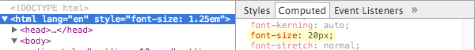

In this case 10rem would equal 200px, i.e. 10 x 20 = 200.

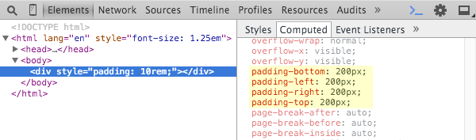

However, if the browser font size was set to 20px, the root font size would instead translate to 25px, i.e. 1.25 x 20 = 25.

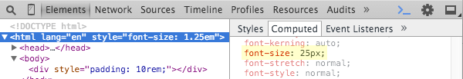

Now 10rem would equal 250px, i.e. 10 x 25 = 250.

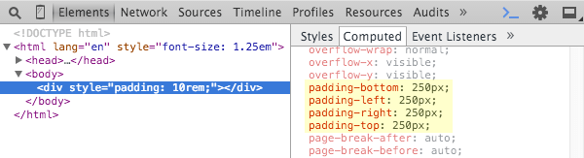

## Summarizing em vs. rem Difference

What all the above boils down to is this:

* Translation of rem units to pixel value is determined by the font size of the html element. This font size is influenced by inheritance from the browser font size setting unless explicitly overridden with a unit not subject to inheritance.
* Translation of em units to pixel values is determined by the font size of the element they’re used on. This font size is influenced by inheritance from parent elements unless explicitly overridden with a unit not subject to inheritance.

## Why Use rem Units:

The greatest power that rem units offer is not just that they give consistent sizing regardless of element inheritance. Rather, it’s that they give us a way to have user font size settings influence every single aspect of a site’s layout by using rem units where we used to use px units.

For this reason the primary purpose of using rem units should be to ensure that whatever default font size a user has their browser set to, the layout will adjust to accommodate the size of text within it.

A site can be designed initially focusing on the most common default browser font size of 16px.

Browser font size 16px

But by using rem units, if a user increases their font size, the integrity of the layout will be preserved, and the text won’t get squashed up in a rigid space meant for smaller text.

Browser font size 34px

And if the user decreases their font size, the entire layout scales down, and they won’t be left with a tiny smattering of text in a wasteland of white space.

Browser font size 9px

Users change font size settings for all kinds of reasons, from strained eyesight to choosing optimum settings for devices that can be vastly different in size and viewing distance. Accommodating these settings allows for much better user experiences.

### Important to Know:

Some designers use rem based layouts in conjunction with a fixed px unit font-size setting on the html element. This is typically done so that a change of font size on the html element can scale overall the design up or down.

I strongly advise against this as it overrides the font size the html element inherits from the user’s browser settings. Hence this prevents the settings from having any effect, and removes the user’s ability to optimize for best viewing.

If you do want to change the font size on the html element, do so with an em or rem value as the root font size will then still be a multiple of the user’s browser font size setting.

This will still allow you to scale your design up or down by changing your html element’s font size, but you’ll preserve the effect of user browser settings.

## Why Use em Units

The key value em units offer is they allow sizing values to be determined by a font size other than that of the html element.

For this reason, the primary purpose of em units should be to allow for scalability within the context of a specific design element.

For example, you might set the padding, margin and line-height around a navigation menu item to use em values.

Menu with 0.9rem font size

This way if you change the menu’s font size the spacing around the menu items will scale proportionately, independently of the rest of the layout.

Menu with 1.2rem font size

In the earlier section on inheritance you saw how quickly keeping track of em units can get out of hand. For this reason, I recommend only using em units if you identify a clear need for them.

## Practical Application

There may be some debate among web designers and I’m sure different people have different preferred approaches, however my recommendation is as follows.

### Use em Units For:

Any sizing that should scale depending on the font-size of an element other than the root.

Generally speaking, the only reason you’ll need to use em units is to scale an element which has non default font sizing.

As per our example above, design components like menu items, buttons, and headings may have their own explicitly stated font sizes. If you change these font sizes, you want the entire component to scale proportionately.

Common properties this guideline will apply to are margin, padding, width, height and line-height settings, when used on elements with non default font sizing.

I recommend that when you do employ em units, the font size of the element they’re used on should be set in rem units to preserve scalability but avoid inheritance confusion.

#### Typically Don’t Use em Units for Font Sizes

It’s quite common to see em units used for font sizing, particularly in headings, however I would suggest that designs are more manageable if rem units are typically used for font sizing.

The reason headings often use em units is they’re a better choice than px units, being relative to regular text size. However rem units can achieve this goal equally well. If any font size adjustment on the html element is made, the heading sizes will still scale too.

Try changing the em font size on the html element in this CodePen to see for yourself:

More often than not, we don’t want our font sizes to scale based on any element other than the root, with only a few exceptions.

One example where we might want em based font sizing could be a drop down menu, where we have second level menu item text sized depending on the font size of the first level. Another example might be a font icon used inside a button, where the icon’s size should relate to the button’s text size.

However most elements in a web design will tend not to have this type of requirement, so you’ll generally want to use rem units for font sizing, with em units only where specifically needed.

### Use rem units for:

Any sizing that doesn’t need em units for the reasons described above, and that should scale depending on browser font size settings.

This accounts for almost everything in a standard design including most heights, most widths, most padding, most margins, border widths, most font sizes, shadows, basically almost every part of your layout.

In a nutshell, everything that can be made scalable with rem units, should be.

#### Tip

When creating layouts it’s often easier to think in pixels but output in rem units.

You can have pixel to rem calculations done automatically via a preprocessor like [Stylus](http://stylus-lang.com/) / [Sass](http://sass-lang.com/) / [Less](http://lesscss.org/), or a postprocessor like [PostCSS](https://github.com/postcss/postcss) with the [PXtoRem](https://github.com/cuth/postcss-pxtorem) plugin.

Alternatively, you can use [PXtoEM](http://pxtoem.com/) to manually do your conversions.

#### Always Use rem Media Queries

Importantly, when using rem units to create a uniformly scalable design, your media queries should also be in rem units. This will ensure that whatever a user’s browser font size, your media queries will respond to it and adjust your layout.

For example, if a user scales up text very high, your layout may need to snap down from a two columns to a single column, just as it might on a smaller screened mobile device.

If your breakpoints are at fixed pixel widths, only a different viewport size can trigger them. However with rem based breakpoints they will respond to different font sizing too.

### Don’t Use em or rem For:

#### Multi Column Layout Widths

Column widths in a layout should typically be % based so they can fluidly fit unpredictably sized viewports.

However single columns should still generally incorporate rem values via a max-width setting.

For example:

|  |  |
| --- | --- |
| 1 |  |
| 2 | .container { |
| 3 | width: 100%; |
| 4 | max-width: 75rem; |
| 5 | } |

This keeps the column flexible and scalable, but prevents it from becoming too wide for the text therein to be comfortably readable.

#### When an Element Should be Strictly Unscalable

In a typical web design there won’t be many parts of your layout that can’t be designed for scalability. However occasionally you will come across elements that really do need to use explicit fixed values for the purpose of preventing scaling.

The precondition for employing fixed sizing values should be that if the element in question were scaled it would break. This really doesn’t come up often, so before you’re tempted to whip out those px units, ask yourself if using them is an absolute necessity.

## Wrapping Up

Let’s have a quick bullet point recap of what we’ve covered:

* rem and em units are computed into pixel values by the browser, based on font sizes in your design.
* em units are based on the font size of the element they’re used on.
* rem units are based on the font size of the html element.
* em units can be influenced by font size inheritance from any parent element
* rem units can be influenced by font size inheritance from browser font settings.
* Use em units for sizing that should scale depending on the font size of an element other than the root.
* Use rem units for sizing that doesn’t need em units, and that should scale depending on browser font size settings.
* Use rem units unless you’re sure you need em units, including on font sizes.
* Use rem units on media queries
* Don’t use em or rem in multi column layout widths - use % instead.
* Don’t use em or rem if scaling would unavoidably cause a layout element to break.

I hope you’ve now built a robust and complete picture of exactly how em and rem units work, and through that know how to best leverage them in your designs.

I encourage you to try the usage guidelines contained in this tutorial for yourself, and enjoy the fully fledged scalability and responsiveness of the layouts they’ll enable you to create.